|  |  |
| --- | --- |
|  | KINGDOM OF SAUDI ARABIA | JAZAN UNIVERSITY  **COLLEGE OF ENGINEERING & COMPUTER SCIENCE** |

ASSIGNMENT -I- 2023-2024 THIRD SEMESTER

|  |  |  |  |
| --- | --- | --- | --- |
| Academic Year | 2023-2024 | Semester | Third |
| Course with code | Software Engineering (371 COMP) | Section | 9382 |
| Type of Assignment | EXPLANATION. | Marks | 10 |
| Date of Announcement | 15 April 2024 | Deadline | 22 April 2024 |

**ASSIGNMENT PROBLEM STATEMENT**

Q1. Explain in detail with diagram: Waterfall Model, Incremental development model. **(2 Marks)**

**Waterfall**

it’s the first software development life cycle (SDLC) model that have been used. It’s also known as linear sequence life cycle, which means that we should totally complete the current phase without overlapping. Very easy to understand and implement. The outcome of current phase is the input of the next phase and vice versa.

**Phases: -**

* **Requirement Gathering and analysis: -**

Documenting the requirements of the software.

* **System Design: -**

The process of specifying both hardware and software requirements and defining the overall system architecture.

* **Implementation: -**

Developing subprograms called units to be integrated on the next phase.

* **Integration and Testing: -**

Integrating the subprograms and test it.

* **Deployment of system: -**

Deploying and setting up the software for the user.

* **Maintenance: -**

it’s the phase which you should update the software and patch the bugs and errors.

Diagram

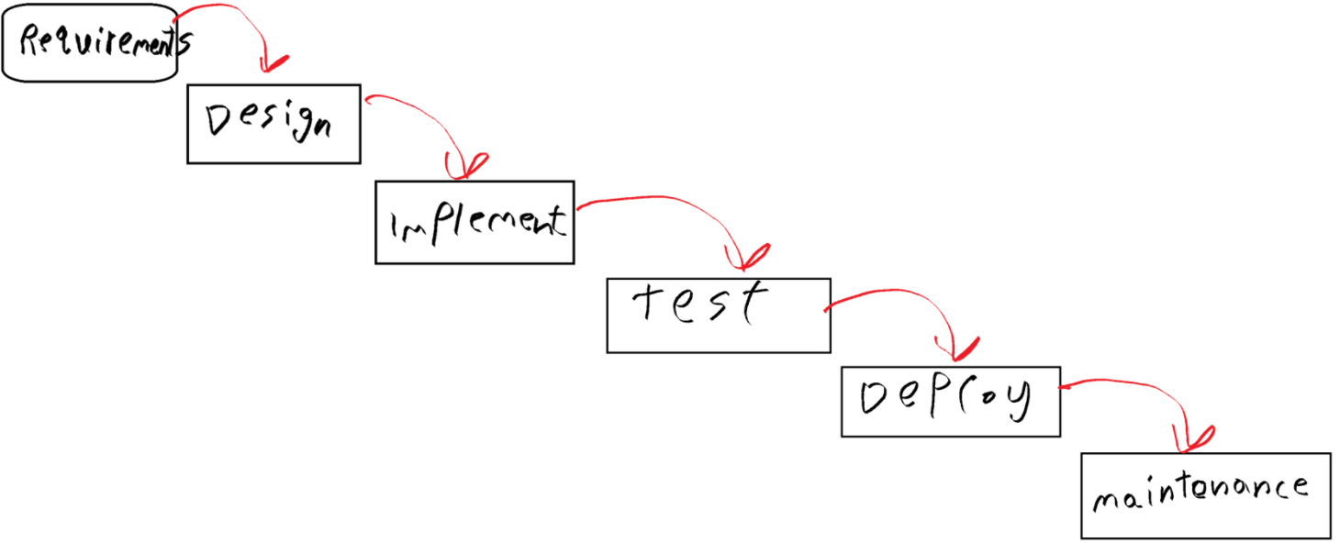

**Incremental development**

It’s iterative nature of prototyping, that’s using linear sequential approach. Taking user feedback, improve it through punch of releases until we got acceptable version of the software.

Note that the requirements is divided into various builds, during each iteration we go through the requirements then design and implement and finally test. At each subsequence we add a feature until we satisfy the requirements.

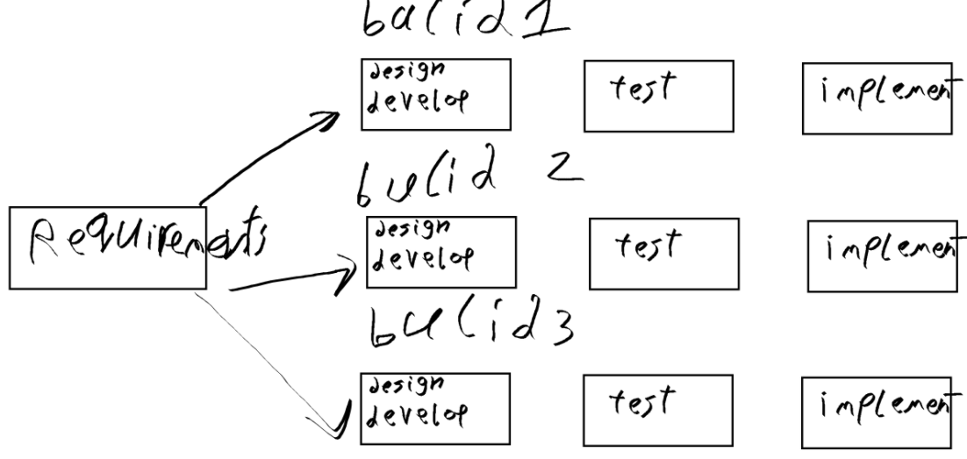

1. What is Requirement Engineering? Illustrate crucial process steps of requirement engineering with neat diagram. (**2 Marks)**

it’s the process of setting the requirements for a certain software.

Crucial process: -

* **Requirements elicitation.**

Gathering requirements with the help of the customer.

* **Requirements analysis.**

Analysing the requirements so that we can know if there’re an inconsistency, defects or omissions, then resolve conflicts.

* **Requirements documentations.**

Design the software and specify the requirements.

* **Requirements review.**

Improving the software requirements specifications.

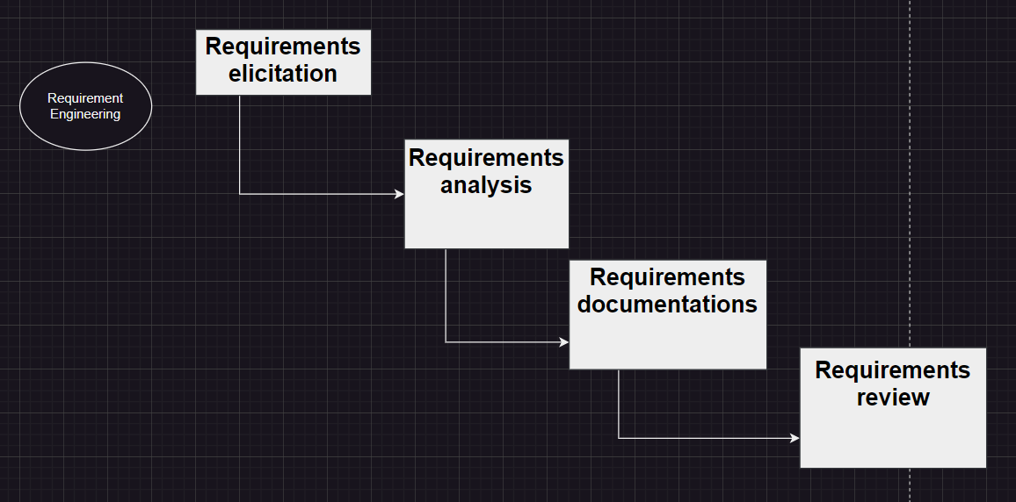

1. Explain different classifications of Non-functional requirements. What are the different categories of metrics? **(2 Marks)**

* **Product requirements**

It’s the requirements which specify that the product should act on a certain way.

* **Organization requirements**

It’s the requirements that is decided by a higher organization.

* **External requirements**

It’s the requirements that is decided from the factors which’s external.

**Categories of metrics: -**

* **Process metrics: -**

It’s the effectiveness and quality of the processes at the software product.

* **Project metrics: -**

It’s the project characteristics and execution.

1. Define: system modeling, Activity diagram, Use case diagram, sequence diagram, class diagram, state diagram. **(2 Marks)**

**System modeling:** the process of making models for your software using UML

**Activity diagram:** it’s a UML diagram that represents the activity of the user

**Use case diagram:** it’s UML diagram that represents the functions and the cases of the software

**Sequence diagram:** It’s UML diagram that shows the sequence of interactions on the software.

**Class diagram:** it’s UML diagram that’s used when the developer use OOP, it’s illustrating the class functions an attributes and the relations between them.

**State diagram:** it’s a UML diagram that describes the states of the system.

1. Draw Use-case and Sequence diagram for ATM **(2 Marks)**

**USE-CASE**

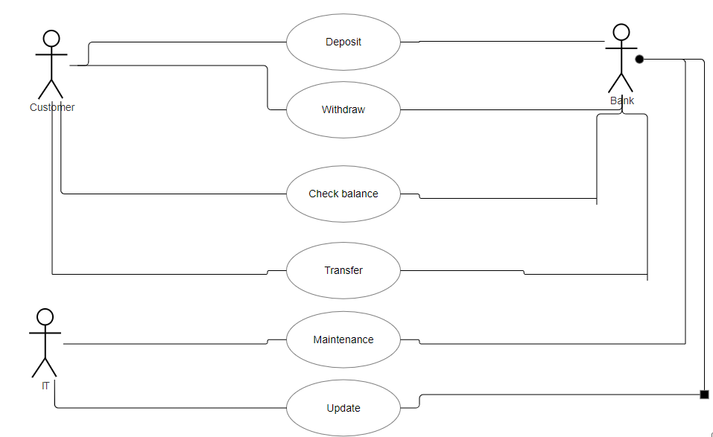

**Sequence diagram**

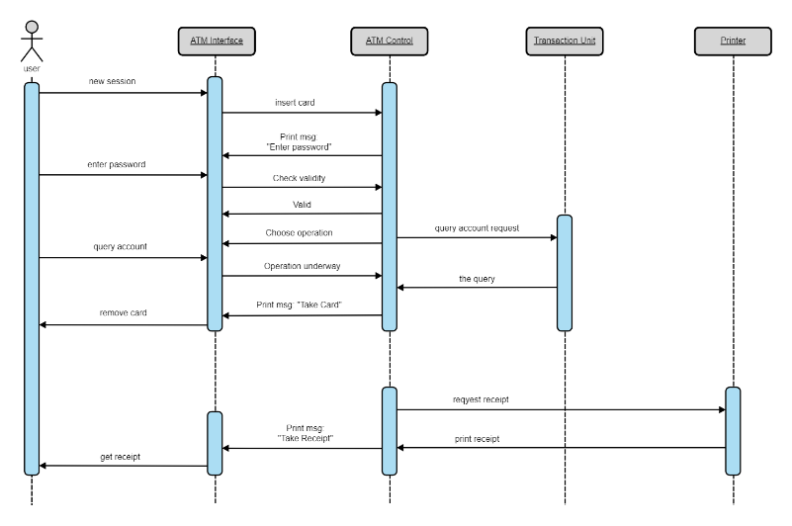

**NOTE:**

1. **COPYING ASSIGNMEN IS INAVLID.**
2. **ALL STUDENTS MUST SUBMIT ASSIGNMENT THROUGH BLACKBOARD ONLY.**